**RAGULANDIRAN M – 22CSR157 || KONGU ENGINEERING COLLEGE**

Prometheus is an open-source system monitoring and alerting toolkit originally built at SoundCloud. It is now a standalone open source project . Prometheus joined the Cloud Native Computing Foundation in 2016 as the second hosted project, after Kubernetes.

**Features,**

1. a multi-dimensional data model with time series data identified by metric name and key/value pairs

2. PromQL, a flexible query language to leverage this dimensionality

3. no reliance on distributed storage; single server nodes are autonomous

4. time series collection happens via a pull model over HTTP

5. pushing time series is supported via an intermediary gateway

6. targets are discovered via service discovery or static configuration

7. multiple modes of graphing and dashboarding support

**Prometheus Installation:**

Username Creation:

sudo useradd \

--system \

--no-create-home \

--shell /bin/false Prometheus

**Command**s:

wget https://github.com/prometheus/prometheus/releases/download/v2.47.1/prometheus-2.47.1.linux-amd64.tar.gz

tar -xvf prometheus-2.47.1.linux-amd64.tar.gz

sudo mkdir -p /data /etc/prometheus

cd prometheus-2.47.1.linux-amd64/

sudo mv prometheus promtool /usr/local/bin/

sudo mv consoles/ console_libraries/ /etc/prometheus/

sudo mv prometheus.yml /etc/prometheus/prometheus.yml

sudo chown -R prometheus:prometheus /etc/prometheus/ /data/

cd

rm -rf prometheus-2.47.1.linux-amd64.tar.gz

prometheus --version

sudo vim /etc/systemd/system/prometheus.service

Prometheus.sevice:

[Unit]

Description=Prometheus

Wants=network-online.target

After=network-online.target

StartLimitIntervalSec=500

StartLimitBurst=5

[Service]

User=prometheus

Group=prometheus

Type=simple

Restart=on-failure

RestartSec=5s

ExecStart=/usr/local/bin/prometheus \

--config.file=/etc/prometheus/prometheus.yml \

--storage.tsdb.path=/data \

--web.console.templates=/etc/prometheus/consoles \

--web.console.libraries=/etc/prometheus/console_libraries \

--web.listen-address=0.0.0.0:9090 \

--web.enable-lifecycle

[Install]

WantedBy=multi-user.target

Node Exporter:

Commands for installation:

sudo mv \

node_exporter-1.6.1.linux-amd64/node_exporter \

/usr/local/bin/

rm -rf node_exporter*

Node exporter file:

[Unit]

Description=Node Exporter

Wants=network-online.target

After=network-online.target

StartLimitIntervalSec=500

StartLimitBurst=5

[Service]

User=node_exporter

Group=node_exporter

Type=simple

Restart=on-failure

RestartSec=5s

ExecStart=/usr/local/bin/node_exporter \

--collector.logind

[Install]

WantedBy=multi-user.target

Service check : sudo systemctl enable node_exporter

sudo systemctl start node_exporter

sudo systemctl status node_exporter

journalctl -u node_exporter -f --no-pager

Reload Promotheus: curl -X POST <http://localhost:9090/-/reload>

**Grafana:**

sudo apt-get install -y apt-transport-https software-properties-common

wget -q -O - https://packages.grafana.com/gpg.key | sudo apt-key add -

echo "deb https://packages.grafana.com/oss/deb stable main" | sudo tee -a /etc/apt/sources.list.d/grafana.list

sudo apt-get update

sudo apt-get -y install grafana

sudo systemctl enable grafana-server

sudo systemctl start grafana-server

sudo systemctl status grafana-server

Grafana UI:

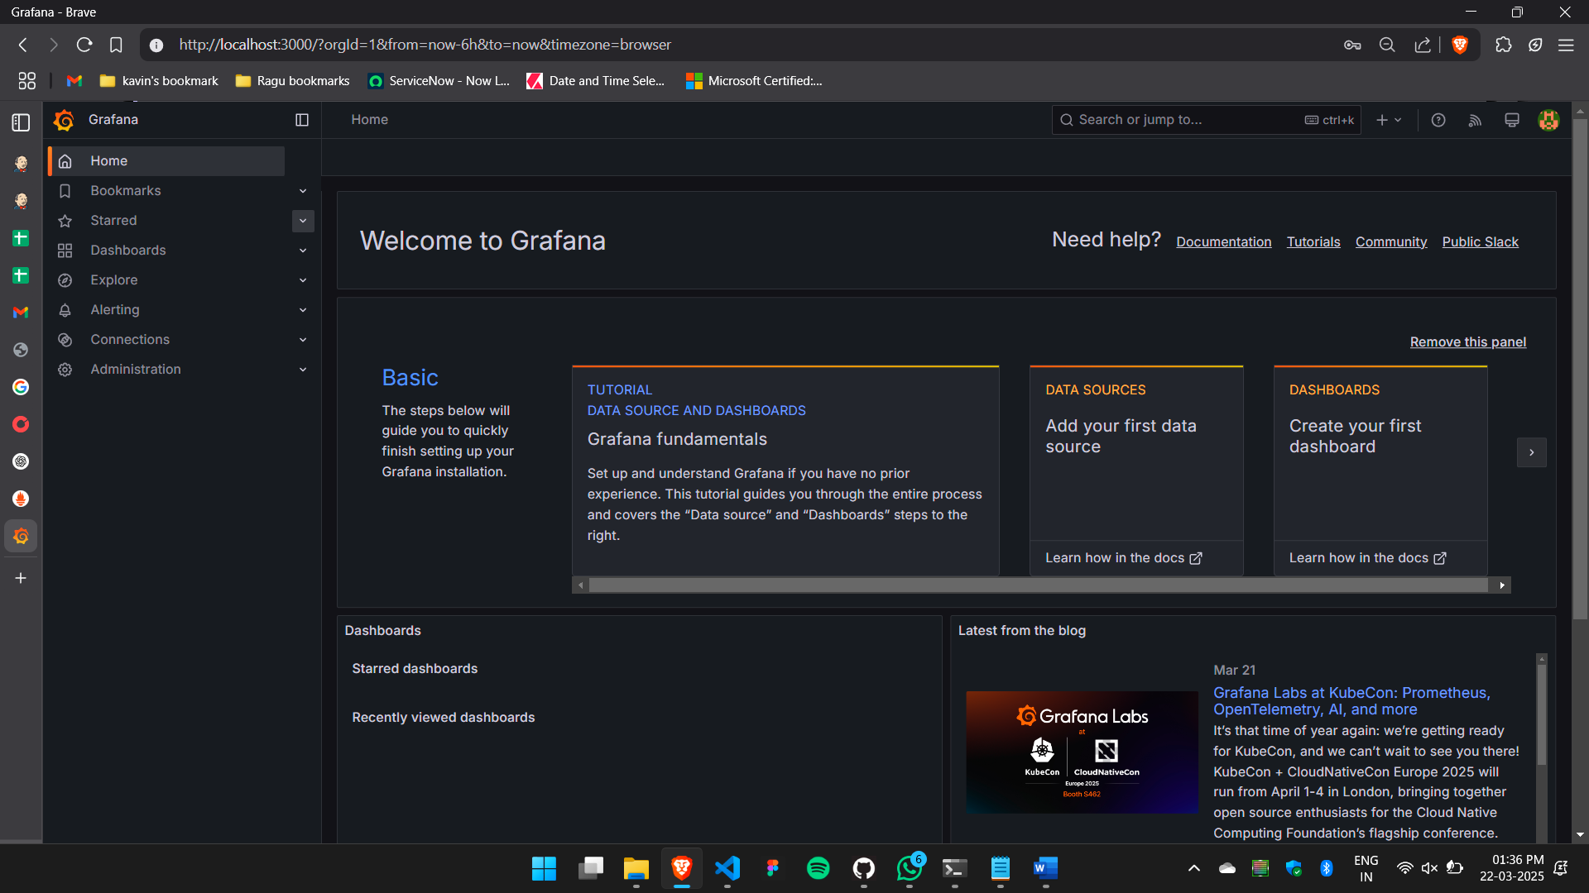

**Status in promethues:**

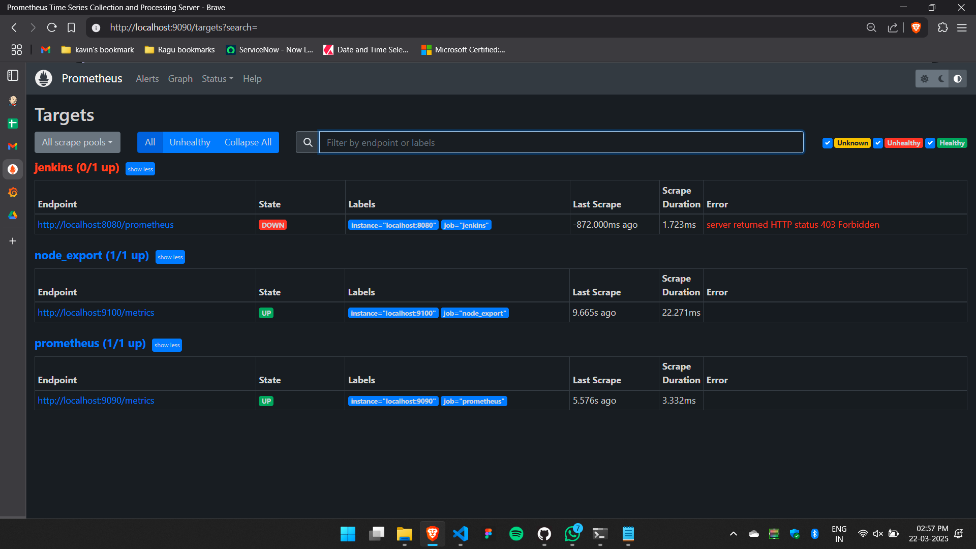

**Metrics in Prometheus:**

Node Exporter:

Dashboard:

Jenkins Overview:

Dashboard:

Prometheus analysis:

rate(node_cpu_seconds_total{mode="system"}[1m])

rate(node_network_receive_bytes_total[1m])

node_load15

Dashboard: (405)

Node Exporter Service metrics,

Dashboard (5174):

Node Exporter Full 0.16,

Dashboard (9096):

1 Node Exporter 1.0.1

